Skyview Picture Retake Schedule

October 16th 2017
1st Period: | Last name A-D
2nd Period: | Last name E-H
3rd Period: | Last name I-M
4th Period: | Last name N-S
5th Period: | Last name T-Z
6th Period: | ALL CALL
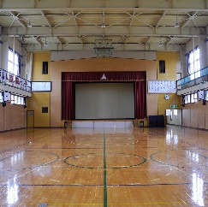

UPPER GYM 1ST –6TH PERIOD

